PROJECT REPORT FOR BACHELOR OF SCIENCE
IN INFORMATION TECHNOLOGY

SPACE SHOOTER



NITESH PAUDEL [5-2-1112-11-2019]

KUSHAL POKHAREL [5-2-1113-9-2019]

PRASIDDHA SHRESTHA [5-2-1113-3-2019]

PRASANNA POKHAREL [5-2-1113-5-2019]

SAMRIDDHI COLLEGE

DEPARTMENT OF SCIENCE AND TECHNOLOGY

APRIL 27, 2021

PROJECT REPORT FOR BACHELOR OF SCIENCE
IN INFORMATION TECHNOLOGY

SPACE SHOOTER

SUPERVISED BY Er. MOHAN BHANDARI FACULTY, SAMRIDDHI COLLEGE

A REPORT SUBMITTED

FOR

SECOND SEMESTER OOP PROJECT

NITESH PAUDEL [5-2-1112-11-2019]

KUSHAL POKHAREL [5-2-1113-9-2019]

PRASIDDHA SHRESTHA [5-2-1113-3-2019]

PRASANNA POKHAREL [5-2-1113-5-2019]

SAMRIDDHI COLLEGE

DEPARTMENT OF SCIENCE AND TECHNOLOGY

FEBRUARY, 2021

DECLARATION

I hereby declare that this project entitled SPACE SHOOTER is based on my original research work. Related works on this project by other researchers have been duly acknowledged. I owe all the liabilities relating to the accuracy and authenticity of the data and any other information included hereunder.

Nitesh Paudel

Kushal Pokharel

Prasiddha Shrestha

Prasanna Pokharel

Date: 2021-04-25
RECOMMENDATION

This is to certify that this thesis entitled SPACE SHOOTER prepared and submitted by Nitesh Paudel, Kushal Pokharel, Prasiddha Shrestha, Prasanna Pokharel for second semester OOP Project of Bachelor of Computer Science and Information Technology awarded by Tribhuvan University, has been completed under my supervision.

ER. MOHAN BHANDARI

Faculty, Samriddhi College

Date: February 2021
ACKNOWLEDGEMENT

We would like to express our deepest appreciation to Samriddhi College for the provision of expertise, and support in the implementation of this project. Without their superior knowledge, the project would like in quality of outcomes, and thus their support has been essential to us. Also, we would like to express our sincere thanks towards our project supervisor Mr. Mohan Bhandari, whose contribution in graphics suggestions and encouragement, helped us to coordinate our project. We would also like to acknowledge with much appreciation to Mr. Jeevan Dhungel who helped us in our overall project, and we would also like to thank the entire staff of Samriddhi College, who gave us the permission to use all the necessary materials to complete the project. We are also thankful and fortunate to get constant support from our seniors and every faculty of BSc.CSIT department which helped us successfully complete our project.
Nevertheless, we express our gratitude toward our family and colleagues for their kind cooperation and encouragement, which help us in completion of this project.

i

ABSTRACT

We can simply relate games as an activity that one engages or amusement for fun. In today’s modern world games have been the sources of income, employment, and opportunity to many giving a tough and healthy competition to many giving a tough and healthy competition to many entertainment industries. Thus, we decided to go on a difficult yet exciting and lesson learning project that was creating a 2D Space Shooter game.

This project presents a Space Shooting game called Space Shooter game, in which the human player defend itself by avoiding the obstacle and by shooting the enemy spaceship. The objective of the game is not to defeat the enemy spaceship, but to provide the player with a challenging and enjoyable experience. To ensure that this objective can be accomplished, the game incorporates graphics, sound, images which enable the Spaceship to be controlled in a manner that mimics natural driving. The paper provides a brief history of graphics work in 2d games, presents the use of graphics techniques in contemporary video games, and discusses the graphics techniques that were implemented in the development of Spaceship.

This project aims to implement the computerized Space shooter game as well as takes the game playing in the easier way hence, user friendly and easy. This project was implemented using C++ also known as Object Oriented Programming.
Keyword: Space Shooter, 2D, obstacle, graphics.

ii

TABLE OF CONTENT

LIST OF ABBREVIATIONS vi

1. INTRODUCTION 1

1.1 INTRODUCTION 1

1.2 PROBLEM STATEMENT 1

1.3 OBJECTVES 2

1.4 SCOPE 2

1.5 OVERVIEW OF REPORT 2

2. BACKGROUND STUDY AND LITERATURE REVIEW 3

2.1 BACKGROUND STUDY 3

2.2 LITERATURE REVIEW 4

3. SYSTEM ANALYSIS AND DESIGN 6

3.1 SYSTEM ANALYSIS 6

3.1.1 REQUIREMENT ANALYSIS 6

3.1.2 FEASIBILITY ANALYSIS 8

3.2 SYSTEM DESIGN 8

3.2.1 ALGORITHM 8

3.2.2 FLOWCHART 9

4. RESULT AND DISCUSSION 10

4.1 RESULT 10

4.2 TEST CASES 12

5. LIMITATION 16

6. FUTURE WORK 17

7. RECOMMENDATION AND CONCLUSION 18

7.1 RECOMMENDATION 18

7.2 CONCLUSION 18

REFERENCES 19

iii

LIST OF FIGURES

FIGURE 3.1.1.1: USE CASE DIAGRAM FOR THE PROJECT 6

FIGURE 3.2.2.1: FLOWCHART OF THE PROJECT 9

FIGURE 4.1.1: SCREENSHOT OF THE MENU SCREEN 10

FIGURE 4.1.2: SCREENSHOT OF THE GAME SCREEN 11

iv

LIST OF TABLES

TABLE 4.2.1: TEST CASE 1 12

TABLE 4.2.2: TEST CASE 2 12

TABLE 4.2.3: TEST CASE 3 13

TABLE 4.2.4: TEST CASE 4 13

TABLE 4.2.5: TEST CASE 5 14

TABLE 4.2.6: TEST CASE 6 14

TABLE 4.2.7: TEST CASE 7 15

TABLE 4.2.8: TEST CASE 8 15

v

LIST OF ABBREVIATIONS

2D : Two Dimensional

3D : Three Dimensional

API : Application Programming Interface

DT : Digital Trends

EXEC : Executable

FPS : Frames Per Second

GL : Graphics Library

GUI : Graphical User Interface

OOPL : Object Oriented Programming Language

vi

1. INTRODUCTION

1.1 INTRODUCTION

The Space Shooter genre is the genre of video games, either in the first-person or third person perspective, in which the player has to defend its Spaceship by avoiding obstacle and by shooting enemy spaceship.
Space Invaders [1] is a 1978 arcade game developed by Tomohiro Nishikado. It was manufactured and sold by Taito in Japan and licensed in the United States by the Midway division of Bally. Within the shooter genre, Space Invaders was the first fixed shooter and set the template for the shoot 'em up genre. The goal is to defeat wave after wave of descending aliens with a horizontally moving laser to earn as many points as possible.
This project is the creation and implementation of an old arcade game using windows OS. There are many reasons for creating this game in the windows. First of all, this game is based on the simple concept, we just need to prevent the Spaceship from colliding with obstacles using the arrow keys and can be easily played by anyone without having gaming knowledge and also does not require high end specification. Secondly, for developing the game is that it is currently growing and has a vibrant market with more people playing PC games than traditional games on consoles. Also, we want to recreate the old memories of this game. lastly, why develop a game, we’ve always has a keen interest in games and wants to understand how they worked. The proposal for this game contains a plan for the development of Space shooter game however as stated before this idea is more accessible and allows for greater enjoyment while still implementing several Space Shooters concepts like Collision, movement, score counter, etc.

.
1.2 PROBLEM STATEMENT

Before starting the project we found out that Modern Space Shooters games requires powerful and large storage hardware with massive graphics processor making it
1

impossible for it to be played in low end PC. So, we built that arcade Space Shooter for low end pc to also play it and enjoy it. Similarly, to setup users for playing games on high end PCs we wanted them from basic controls, so we went for this project.

1.3 OBJECTIVES

The objectives of our project are the following:

● To know the mechanism on how this game runs.
● To recreate the game from video game console to PC game.
● To play this game as a fun playing game.

1.4 SCOPE

Our project is applicable in any place that has access to a computer regardless of its specifications and its hardware capabilities. This is made possible by the versatility of C++ language.

1.5 OVERVIEW OF REPORT
The report altogether contains three chapters. The first chapter “Introduction” contains whole information of the project “Space Shooter”. It is sub-headed into nine topics. The chapter contains the background, problem statements, objectives, applications, project features, and feasibility analysis and work schedule of our project. Similarly, chapter two consists of the literature review of the report. In addition, chapter three is all about the methods by which our project is being completed. Under methodology, block diagram with working mechanism and the system flow diagram of the project. The chapter four epilogue consists of the details of the details of the results found, problems faced during the building project, remaining work and conclusion of the project.

2

2. BACKGROUND STUDY AND LITERATURE REVIEW

2.1 BACKGROUND STUDY

Our team decided to port Space Shooter Game in C++ because first off, it is a well- liked game and thus our program is familiar to the users as there is a high chance that user has at least played the game. Having familiarity with the game is important because it will be easier to convince people to give a chance to our program instead of trying to make them give a chance to something that they have no idea what it is and no idea whether they will like it.
Secondly, we are also starting out with very beginner level knowledge of OOPL. Thus, we wanted our project to be moderately challenging without hopeless levels of difficulty that would put us of OOPL.

3

2.2 LITERATURE REVIEW

For any game to prove itself irresistible to play, it should have a perfect amalgam of hassle and reward. Psychologist Mihaly Csikszentmihalyi terms this feeling “flow” and swaying below this feeling leads to sense of ennui and above it leads to anxiety. Our game should provide exactly that.
Codes that have been written by someone else is often difficult to understand and horrible to maintain and extend. Countless program units, like classes, or functions, are very large, some of them with thousands of lines of code. Too many dependencies between these units lead to unwanted side effects if something is changed. While our team might not be a team of strong software architects we’ll try to implement what they do so that our program would not look like a “big ball of mud”. Understanding basics of software entropies is a very good start and yes, we’ve already started doing some homework to implement that in our “Space Shooter” game.
Mastering how to work with vectors in game development is one of the core building blocks to becoming a professional games programmer and gives you the ability to implement most of the mechanics found in modern games. Positioning of objects simply requires vectors and it will be used quite commonly in our project.
One of the important aspect of good optimal game play is clear goal. And yes in our game, the rule is very simple. Which means that the ones playing would not need to spend large chunks of their precious time to know what’s going around in the game.[1]

4

3. SYSTEM ANALYSIS AND DESIGN

3.1 SYSTEM ANALYSIS

There are two actors in our project: spaceship and obstacles. Main objective of the spaceship is to avoid the obstacle by moving left right up and down through the help of arrow keys and obstacle has been added there just to make the game a little bit difficult and enjoyable to play.
Talking about our vital actor game controller, it does most of the heavy lifting like showing menu, giving the instruction on how to play and most importantly starting the game. All these tangled up make a fine recipe for an exciting looking game.
Some major entities of our program with their functions are:
- Show Menu: It shows the menu with instruction, exit and option to start the game.
- Start Game: It initializes the game and the various entities that extend from it.
- Show Obstacle: It shows the obstacles that player must avoid to move forward.
- Game Over: After colliding with the obstacles spaceship gets destroyed and game is over and score gets displayed.

3.1.1 NON FUNCTIONAL REQUIREMENTS
- ACCESSIBILITY
One can easily gain access to our game on downloading it via internet. Users won’t have a problem downloading it from devices such as a pen drive. It is free of cost and provides a great entertainment to lure away user’s boredom.
- PERFORMANCE
The game that we’ve built is smooth and can be played without any interference. It should run fine in your computer screen without lags or glitches.
- APPEARANCE
Space Shooter game is a arcade shooting game in which players have to defend their spaceship by avoiding obstacles and by shooting enemy Spaceship. Most of the peoples might have played this game.

3.1.2 FEASIBILITY ANALYSIS

i. TECHNICAL FEASIBILITY

Our project is technically feasible because the code is written in C++, so it doesn’t require much time and great technical skills.

ii. OPERATIONAL FEASIBILITY

Our project is operationally feasible because it does not require any special operational skills to run all you need to run this game is the project file which is easily available.

iii. ECONOMIC FEASIBILITY

This game is free to download and there is no in game purchases. So, anyone with interest to play this game can play this game without any cost.

iv. SCHEDULE FEASIBILITY

Our game only required about 15 days to code. So, it is feasible in any schedule.

6

3.2 SYSTEM DESIGN

3.2.1 ALGORITHM

STEP1 Start
STEP2 Display loading screen
STEP3 Display menu
STEP4 If enter key=start game
If yes, start game, go to step9
If no, display other chosen options, go to step3
STEP5 If enter key=High score
If yes, start game, go to step 9
If no, display other chosen options, go to step3
STEP6 If enter key=credits
If yes, Display credits
If no, display other chosen options, go to step3
STEP7 If enter key=instructions
If yes, Display instructions
If no, display other chosen options, go to step3
STEP 8 If enter key=Exit
If yes, go to step
If no, go to step3
STEP 9 If arrow key = left
If yes, move spaceship left
If no, move spaceship according to desired key pressed by user
STEP 10 If spaceship collide with obstacle
If yes, display game over and go to step11
If no, go to step9
STEP 11 Display high Score
STEP12 End

7

3.2.2 FLOWCHART

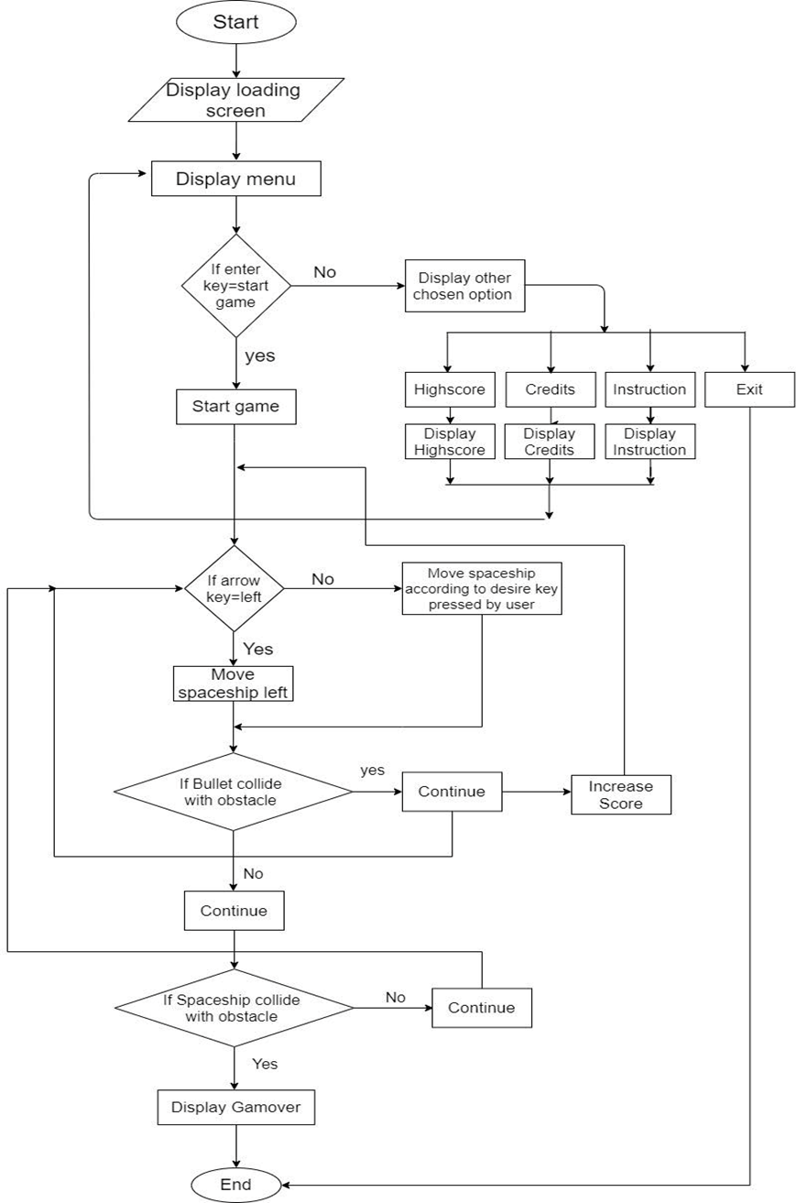

FIGURE 3.2.2.1: FLOWCHART OF THE

PROJECT

8

4. RESULT AND DISCUSSION

4.1 RESULT

The final output of our program is following:
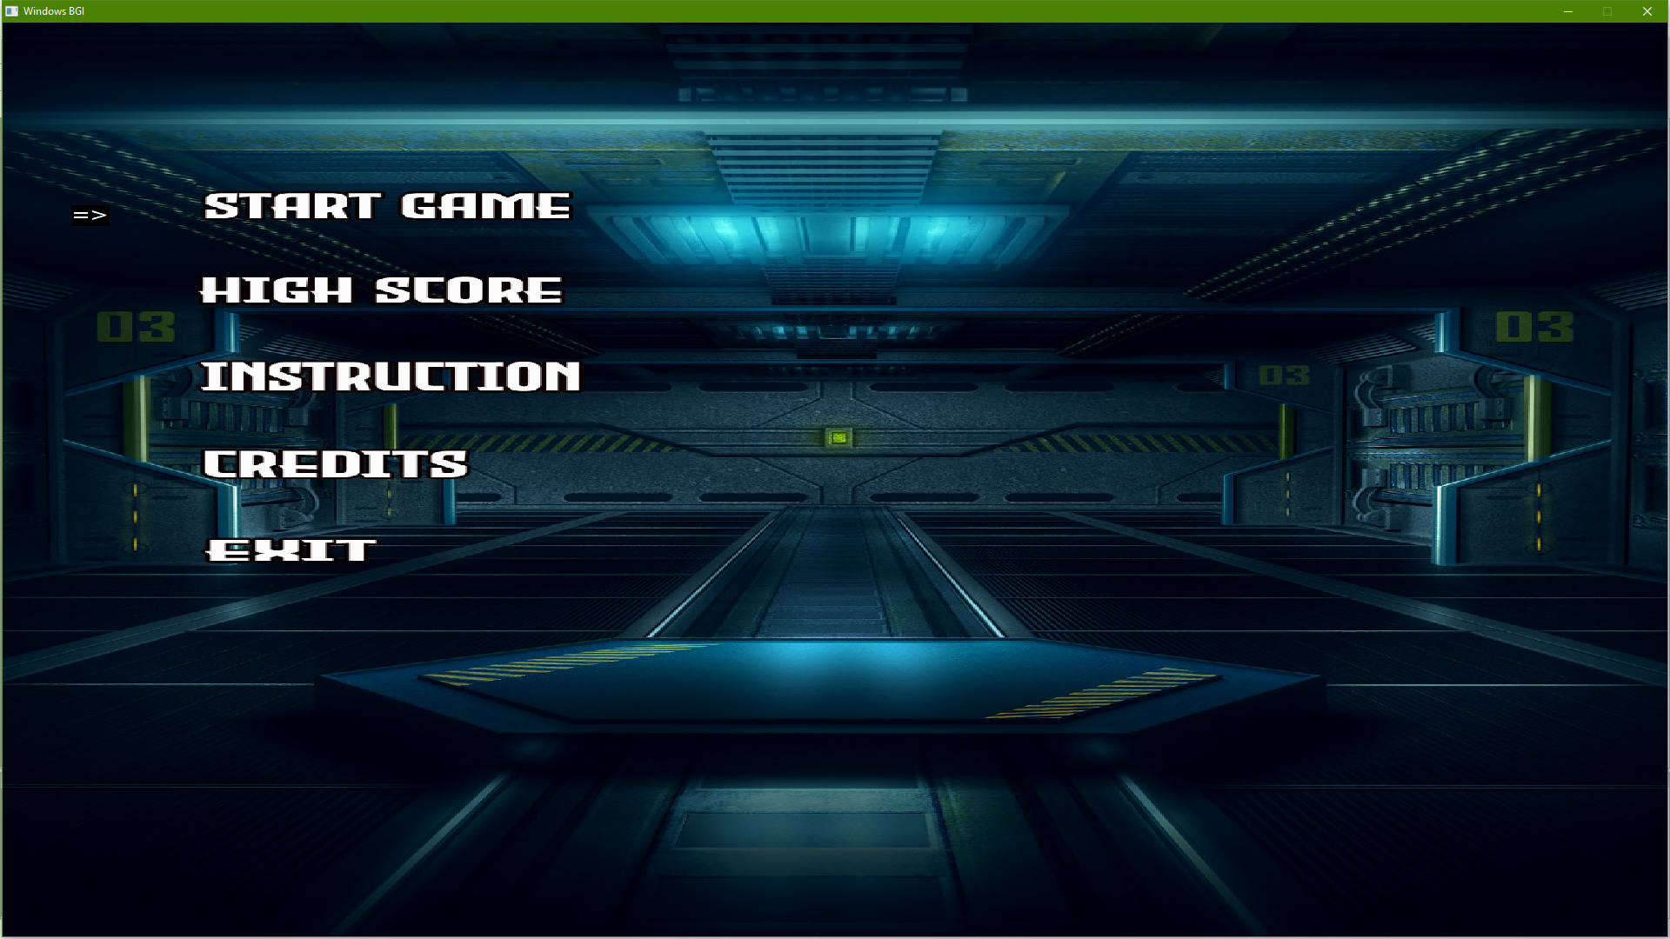

FIGURE 4.1.1: SCREENSHOT OF THE MENU SCREEN

The code was written to produce an average menu screen. The menu was made minimalistic and simple. For the menu, an image was selected as background and text was written on top through code.

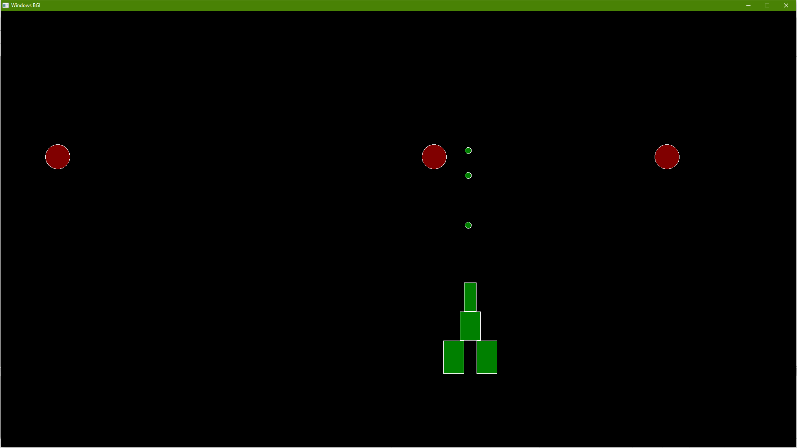

FIGURE 4.1.2: SCREENSHOT OF THE GAME SCREEN

9

4.2 TEST CASES

Test Case ID | LOAD_001
Test Case | Showing Menu before starting the game
Description
Pre-Requisites | a. G++ Compiler
Test Scenario | On Opening exec file
Test Data | Desired Screen Size (1920 x 1080)
Steps | Expected Result |  | Actual Result | Pass/Fail
a. Open exec file | Menu should |  | Menu was
b. Provide desired | Menu should |  | Menu was | Pass
b. Provide desired | be shown |  | shown | Pass
screen size | be shown |  | shown

TABLE 4.2.1: TEST CASE 1

Test Case ID | LOAD_002
Test Case Description | Showing of the main game screen after starting the game
Pre-Requisites | a. Running instance of the game
Test Scenario | On pressing Start Game
Test Data | Desired Screen size(1920 x 10800
Steps | Expected Result | Actual Result | Pass/Fail
a. Move the bird | Main Screen should | Main Screen was | Pass
b. Collide with object | be shown | shown | Pass

TABLE 4.2.2: TEST CASE 2

10

Test Case ID | MOVE_001
Test Case Description | Movement on keypress of space key only
 | a. Image Loader Library
Pre-Requisites | b. G++ Compiler
Test Scenario | On key press of arrow keys
Test Data | <Arrow Keys>
Steps | Expected Result |  | Actual Result | Pass/Fail
a. Run the game
b. Start the game | Spaceship should move |  | Spaceship moved | Pass
c. Press < Space >

TABLE 4.2.3: TEST CASE 3

Test Case ID | MOVE_002
Test Case Description | Movement on keypress other than arrow keys
 | a. Image Loader Library
Pre-Requisites | b. G++ Compiler
Test Scenario | On keypress other than arrow keys
Test Data | < G >
Steps | Expected Result |  | Actual Result |  | Pass/Fail
a. Run the game
b. Start the game | Spaceship should not |  | Spaceship didn’t move |  | Pass
c. Press key other than < | move |  | Spaceship didn’t move |  | Pass
Space>

TABLE 4.2.4: TEST CASE 4

11

Test Case ID | SCORE_001
Test Case Description | Increasing score after destroying obstacles
Pre-Requisites | a. Free GLUT Library
Pre-Requisites | b. G++ Compiler
Test Scenario | After destroying Obstacles
Test Data | < Arrow Keys>
Steps | Expected Result | Actual Result | Pass/Fail
a. Run the game | The score counter should | The score counter
b. Start the game | The score counter should | The score counter | Pass
b. Start the game | increase | increased | Pass
c. Dodge the obstacle | increase | increased

TABLE 4.2.5: TEST CASE 5

Test Case ID | SCORE_002
Test Case Description | High score check after ending the game
Pre-Requisites | a. Free GLUT Library
Pre-Requisites | b. G++ Compiler
Test Scenario | On ending the game after certain score
Test Data
Steps | Expected Result |  | Actual Result | Pass/Fail
a. Run the game | The score should be |  | The score was
c. Dodge the obstacles | The score should be |  | The score was
c. Dodge the obstacles | recorded in |  | recorded in | Pass
d. End the game with | recorded in |  | recorded in | Pass
d. End the game with | high score. |  | high score.
certain score | high score. |  | high score.

TABLE 4.2.6: TEST CASE 6

12

5. LIMITATION

“Imperfection is sometimes way too perfect.”, The saying had to be brought up while casting some light on our not so flawless game, “Flappy Bird”. Although the game was built to be better than the original, “Flappy Bird” with the newly added parallax effect, improved controls to make users more addictive by maintaining science of flow, animation on death and so on, it still lacks few things.

1.Vsync not enabled: The game mode used to implement VSync could not find required extension in most of our test devices which had intel HD driver. With this, we could have watched the monitor’s max refresh rate. If the FPS of our game was equal to or higher than the refresh rate, VSync would have been enabled.

- Screen tearing on Nvdia GPU: This project also failed to prevent screen tearing on Nvidia GPU, and that explains why it didn’t run on Macbook Air 2010 (one of our test device) which had Nvidia GPU. Not only that, also due to unavailability of free Glut, the game failed to run in the terminal.

- Highscore initialized to 0 after every session: Achievements are something to brag about if you are a human and if a human ever plays Flappy Bird, they have to show others if they get past double digits or not. Unfortunately, after a session ends on the terminal, our game is initializing the high score to 0 littering all your progress in thin air. Had there been works done on file handling, this could have been prevented.

- Absence of Wake locks: The game fails to prevent the processor from sleeping or dimming because there is no addition of Wake locks.

Other than these flaws we do not know of any other limitations of our game Flappy Bird.

13

6. FUTURE WORK

After working with flappy bird, we’ve come a long way to get some understanding about OpenGL and game development. We can now go ahead to work with some game engines to add more animations, and produce a 3D version of the game.

1.3D version of the game: Previously, players of this game played the game on third person view and had a very little feeling of what it means to be the bird Fapy. The game in the future can promise you with the perspective of the bird which would further more enhance your experience with the game.

- Networking involved: Furthermore, we can create a community of the game lovers after we work on the networking so that you could know about the global leaders of the game.

- Addition of Wakelocks: We can also work with PowerManager Wakelocks to prevent your device’s processor from sleeping or dimming. The game runs on terminal and this might prevent the processor from dimming for now but we can’t be satisfied here.

4.Flapping of wings: Animations is another aspect of our game that we failed at completely. While there was a death animation, we can show that the bird Fapy is flapping its wings doing all sorts of crazy stuffs while getting past the obstacles. This is achievable in the future and we are looking to bring changes in this aspect of our game.

- Vsync enabled: Implementation of VSync would let us to know if FPS of our game was higher than monitor’s max refresh rate or not. We are therefore also thinking about implementation of VSync.

- High score initialization with file handling: Highscores in this project have been a headache for us as it initia zero on each session. That should’nt be the case after file handling is implemented here. Or there are some other aspects we’ve not looked into that keeps changing the highscore after every session.

14

7. RECOMMENDATION AND CONCLUSION

7.1 RECOMMENDATION

To those people who might take our report as reference we have some suggestions and recommendations:

First Recommendation: Dont use OpenGL. It might seem counter intuitive to say that considering what this report is on, but trust us, instead of using OpenGL that has many precompiled libraries and functions to make a game, try to make your own game engine. This will not only help to make you more familiar with the programming language of your choice, it also helps to learn the many aspects of game development and programming that might be lost to you if you use OpenGL.

Second Recommendation: Be sure of your expectations vs what you can do. When we started this project, we had many expectations from ourselves and from the game as a whole. Many things like rendering custom font for Score and Highscore display was not possible because the strike font library of OpenGL only has Roman font and using any other fonts like bitmap instead of strike font would ruin the game animation and game texture. So, before you have expectations be sure that your expectations are ahievable in the time that you have.

7.2 CONCLUSION

Those who are willing to start game development with C++ have a lots to look into from game engines to APIs, normal physics to vast camera movements and so much more. Just getting a grasp of basics of simple 2D games is a good way to go for it. We would advice you to get a firm knowledge on the concept of class and objects before starting a project like this. This is a long journey and in it comes a lesson on each turns.

In a nutshell, it was an exceptional project for us as we were working with graphics in C++ for the very first time. There were a lot of frustrations as we hit the dead end a lot of times on various aspects of the development. However, all those grinding gave us some knowledge about API and object oriented programming. This was indeed a great experience for our team.

15

REFERENCES

[1] G. Stevens, “Why you can’t stop playing Flappy Bird | The Daily Dot”, 2
March 2020. [Online]. Available: https://www.dailydot.com/parsec/psychology-flappy-bird-addiction/. [Accessed 27 March 2021].

- “LearnOpenGL”, LearnOpenGL, 12 May 2017. [Online]. Available: https://learnopengl.com/Getting-started/Review. [Accessed 27 March 2021]

- M. Peckman, “Time”, Times, 03 February 2014. [Online]. Available: https://time.com/4034/no-you-dont-have-to-play-flappy-bird/. [Accessed 03 April 2021]
- S. Roth, Clean C++: Sustainable Software Development Patterns and Best
Practices. Bad Schwartau, Schelswig-Holstein: Apress 2017

- “Vector Maths for Game Dev Beginners”,GameDev.net, 16 May 2020. [Online]. Available: https://gamedev.net/tutorials/programming/math-and-physics/vector-maths-for-game-dev-beginners-r5442/. [Accessed: 06 April 2021]

- “’Flappy Bird’ holds the key for figuring out the perfect difficulty in video
games”, Technical.ly Brooklyn, 31 August 2016. [Online]. Available:

https://technical.ly/brooklyn/2016/08/30/nyu-game-center-flappy-bird-case-study/. [Accessed: 06 April 2021]

16

